

BIM User Guide: April 2025

**ACO BalconyDrain - shallow drainage**

**User Guide for Autodesk Revit files**

**Introduction and overview:**

1. There are 3 families in the model incorporating Based on sizes combination.
2. Families are assigned to Omni class 23.70.50.24: Rainwater Removal.
3. User can select each family from the type of selector in the project environment.

**File characteristics and contents:**

1. File is under 2MB and designed to be user friendly.
2. File is tagged with manufacture’s name, specification codes and other relevant information.
3. Bill of materials (schedules) can also be accessed from the project environment.

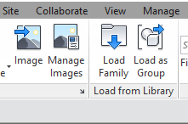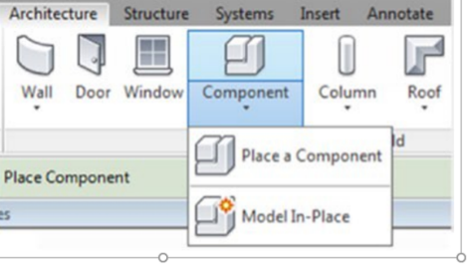

**Loading ACO BalconyDrain into the project:**

1. Download the ACO BalconyDrain rfa file and save it to a suitable location.
2. Load the families into the project file.

1. Navigate to the “Insert” icon on the Revit ribbon and click “Load Family”
2. The file can now be placed into your project. Navigate to the “Architecture/Component” icons on the Revit ribbon and click “Place a Component”

**Placing of families**

1. Click on the model – At properties tool bar, it will display family name and family types.

1. Selection of Gratings: At properties tool bar, it will display gratings<Generic models> click on the Down arrow for selecting four different gratings.

1. Warning indication: for selection of Outlets: If user selects maximum number of outlets should exceed the length of the channel. then the warning pop will display as shown in image.

Note indication: "Position of the additional outlet is always towards the right side of the previous outlet"

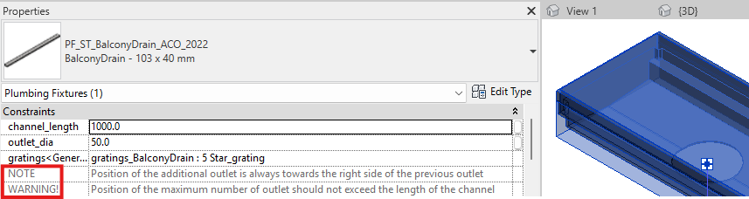

**Material Library:**

The ACO BalconyDrain files contain materials that are already pre-loaded into the components. When loading the ACO BalconyDrain files into your project the pre-loaded materials will automatically transfer through.

**Schedules and quantities:**

The information such as article number, GTIN data, weight, installation guidelines within the parameters is stored as “shared Parameters” so can easily be appeared when creating a schedule and quantities in the project environment.